PhD Viva Voce
Candidate Name: | Aaron Manaseh | 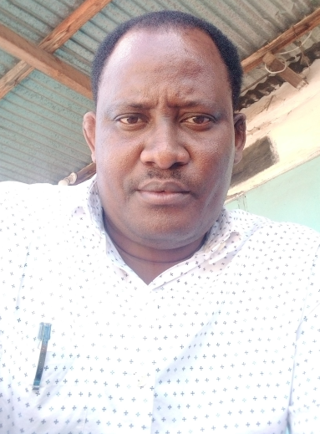
Registration Number: | 2018-07-00013
 | University of Dar es Salaam
 | School of Education

Qualifications Attained:
Mr. Aaron Manaseh is a PhD candidate (by Coursework and Dissertation) in the Department of Educational Foundation Management and Lifelong Learning (EFMLL), School of Education at the University of Dar es Salaam (UDSM). He completed a Bachelor of Education in Science at UDSM in 2009. Then, he progressed to a Master of Education Management and Administration (MEMA) in 2010, which he completed in 2012 at the same university. Aaron is an Assistant Lecturer in the Department of Educational Foundations and Management, Faculty of Education at Mkwawa University College of Education (MUCE). At MUCE, Aaron teaches educational management, administration, and leadership courses. His research areas of interest include instructional leadership, educational leadership preparation, and entrepreneurship education for educational leaders.

Title of Dissertation: | Discursive Construction of Prospective Educational Leaders’ Subjectivities in Selected Higher Learning Institutions Towards Enhancing Educational Leaders’ Capacity in Tanzania
Date of Viva Voce: | Friday 01st December, 2023
Venue: | SoED Board Room
Time: | 10: 00 a.m
Supervisor: | Dr. Moshi Amsi Mislay and Dr. Simon Peter Ngalomba

Abstract:
Successful educational leadership depends on preparing prospective educational leaders (PELs) appropriately. However, current data in Tanzania indicate that graduate educational leaders demonstrate an inadequate leadership capacity, partly attributable to their preparation in higher learning institutions (HLIs). Previous studies in Tanzania have reported more on the outcome of PELs’ preparation programmes and not much on the context, input, and process through which PELs’ subjectivities are constructed in HLIs. This study critically analysed PELs’ preparation programmes in HLIs to establish how these programmes have discursively constructed PELs’ subjectivities towards enhancing their leadership capacity to narrow this knowledge vacuum. Specifically, the study examined the evolution of PELs’ preparation programmes offered by universities in Tanzania; analysed universities’ curricula for PELs’ preparation to establish the way they discursively construct PELs’ subjectivities towards enhancing their leadership capacity; analysed pedagogy for PELs’ preparation to ascertain the way it discursively construct PELs’ subjectivities towards enhancing their leadership capacity; and examined how labour market discourses reshape the development and reform of PELs’ preparation in Tanzania universities towards enhancing leadership capacity among PELs. The study adopted critical and poststructuralist paradigms and a qualitative research approach. Professional Socialisation Theory guided the study. A case study design was employed to collect data from 117 participants. The researcher purposively selected these participants from two purposively sampled universities and four Municipalities. The researcher used interviews, focus group discussions, classroom observations, documentary analysis, and an open questionnaire to collect data. Thematic discourse analysis and critical discourse analysis methods were employed to analyse data. Findings indicate that PELs' preparation programmes evolved from a single module to well-structured courses integrated into teacher preparation degree programmes and fully fledged degree programmes for PELs' preparation through adoption from foreign universities and a university within Tanzania. Second, curricula for PELs' preparation foreground the construction of PELs' subjectivities in terms of theoretical knowledge over practical knowledge and knowledge of the core functions of educational leaders. They also construct PELs' subjectivities in a discriminatory manner without contemporary issues relevant to PELs’ preparation in the 21st century. Third, transmissive lecture pedagogy constructs PELs’ subjectivities hierarchically, depriving PELs of the curiosity to learn educational management and administration courses with critical thinking. It also constructs memorisation ideology, passive, and dependent learning identity among PELs. The seminar group discussion pedagogy empowers PELs to actively negotiate power/knowledge with course instructors and reconstruct an active learning identity deprived in the context of transmissive lectures. Independent study pedagogy constructs PELs’ independent learning identity through individual and group assignments. Finally, labour market discourses reshape the development and reform of PELs’ preparation through the introduction of learning units, course modules, elective and core courses, teaching subjects, a full degree programme on policy planning and management, as well as the elimination of a work experience criterion in the admission requirements for some fully fledged degree programmes for PELs’ preparation. It also reshapes academics’ pedagogical orientations from emphasising traditional theories and principles of educational management and administration to accentuating knowledge of entrepreneurial leadership in education, employment creation, creativity, and innovation during instruction. The study concludes that PELs’ preparation programmes offered in the studied HLIs reproduce an overall disempowering effect among PELs by downplaying practical and contemporary issues relevant to PELs’ preparation. They also construct passive and dependent learning identities, negatively impacting the development of sound leadership capacity among PELs. The study recommends reforming the programmes to improve the relevance of their curricula and pedagogy. Future studies should cover observations of field-based training to establish how it constructs PELs' subjectivities to offer a complete picture of the preparation process.

Panel Members
No | Name | Designation | Rank | Unit
 | Prof. Abel Ishumi | Chairperson | Professor  Emeritus | SoED-EFMLL
 | Dr. Hillary Dachi | Representing External Examiner | S/Lecturer | SoED-EFMLL
 | Dr. George Kahangwa | Internal Examiner | S/Lecturer | SoED-EFMLL
 | Dr. Moshi Mislay | Candidate’s Supervisor | Lecturer | SoED-EFMLL
 | Dr. Nkanileka Mgonda | Head of the relevant department (or his/her appointee) | S/Lecturer | SoED-EFMLL
 | Dr. Abert Tarmo | Co-opted Member (appointed by College/School/Institute | S/Lecturer | SoED-EPCS
 | Dr. Boniface Raymond | Co-opted Member (appointed by College/School/Institute | S/Lecturer | SoED-EFMLL
 | Dr. Perpetua Urio | Appointee of the Principal for PhD only) | S/Lecturer | DUCE-EFMLL

